PYTHON CODE (GAS, TEMPERATURE, HUMIDITY, PRESSURE)

|  |  |
| --- | --- |
| **Date** | 10 NOVEMBER 2022 |
| **Team ID** | PNT2022TMID42967 |
| **Project Name** | GAS LEAKAGE MONITORING AND ALERTING SYSTEM FOR INDUSTRIES |

PYTHON CODE

import random

print('Hazardous Gas Level=',str(random.randint(0,100))) print('Temperature=',str(random.randint(0,100))) print('Humidity=',str(random.randint(0,100))) print('Pressure=',str(random.randint(0,100)))

OUTPUT:

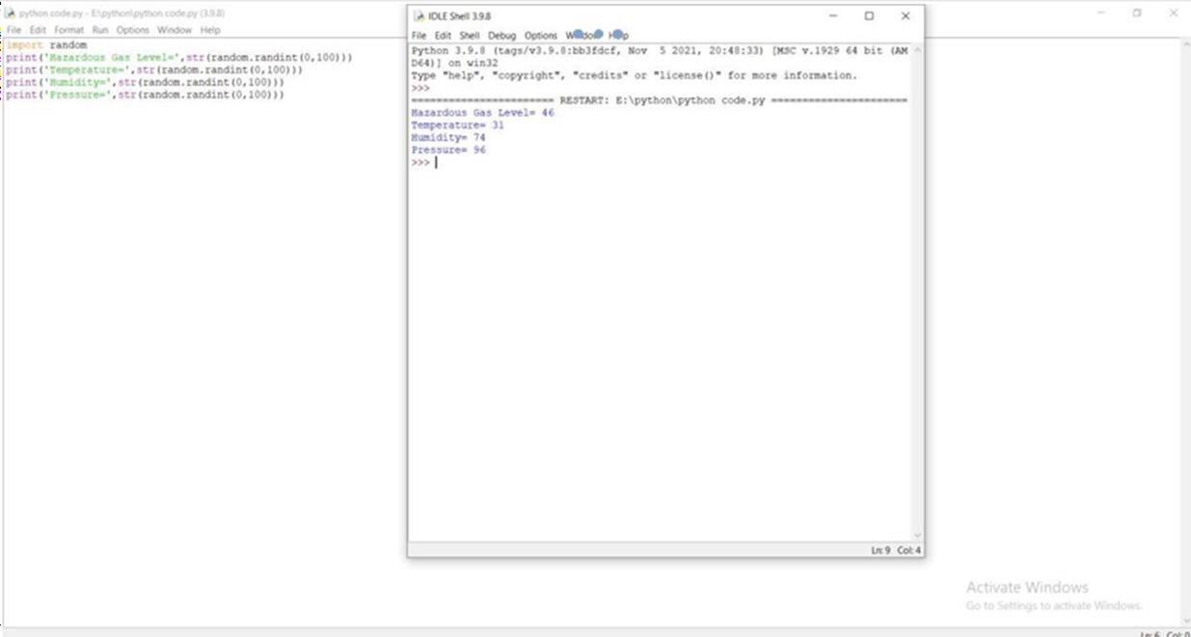

*1*

